TARDIS

The Doctor’s Tardis lands on the Red Planet.
There is only red light.
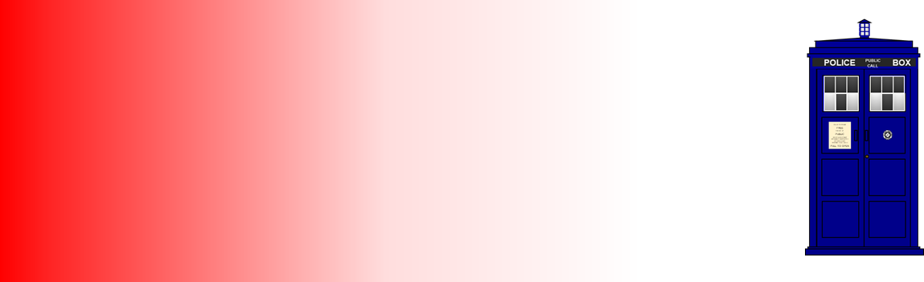

1. What colour will the TARDIS look on the Red Planet?
Put a tick (✓) in the box next to the best answer.

A | Blue
B | Red
C | Purple (magenta)
D | Black

2. Why do you think it looks this colour?
A | There is only red light
B | Blue does not reflect red light
C | The paint is blue
D | The eye adds the red light to the blue

Physics > Big idea PSL: Sound, light and waves > Topic PSL2: How we see > Key concept PSL2.2: Seeing in colour
Diagnostic question
TARDIS

Overview
Learning focus: | Light has colours that are seen when reflected by bodies.
Observable learning outcome: | Work out the colour a coloured object looks in light that is a different colour to the object (primary colours).
Question type: | Two-tier multiple choice
Key words: | Reflect, absorb

What does the research say?
Martinez-Borreguero et al. (2013) found that students’ explanations of colour formation were most often of the form: ‘bodies have colours that are seen when they reflect light’. They reformulated this explanation to: ‘light has colours that are seen when it is reflected by bodies’ and asked students to consider which statement they found most useful. They found that a shift in focus to the latter made the origin of misunderstandings more explicit and resulted in a significant improvement in students’ longer term conceptual change.
In a sample of 86 secondary students, over 60% thought the colour perceived is the sum of the colour of light plus the colour of the object. In the same study, over 45% of secondary teachers (n=64), who were mostly science specialists, had the same misunderstanding (Martinez-Borreguero et al., 2013). A further 8% of students thought the colour perceived would always be the same as the colour of the object, and 9% that the colour perceived would always be that of the illuminating light. Only one student and eleven teachers in these samples were consistently correct in identifying the perceived colour of a coloured object in different colours of light.
This question investigates how effectively students can apply their understanding of colour formation to a novel situation in which the coloured object reflects none of the light that falls on it. It challenges all three of the misunderstandings described above.
Ways to use this question
Students should complete the questions individually. This could be a pencil and paper exercise, or you could use an electronic ‘voting system’ or mini white boards and the PowerPoint presentation. The follow on question will give you insights into how they are thinking and highlight specific misconceptions that some may hold.
If there is a range of answers, you may choose to respond through structured class discussion. Ask one student to explain why they gave the answer they did; ask another student to explain why they agree with them; ask another to explain why they disagree, and so on. This sort of discussion gives students the opportunity to explore their thinking and for you to really understand their learning needs.

Differentiation
You may choose to read the questions to the class, so that everyone can focus on the science. In some situations it may be more appropriate for a teaching assistant to read for one or two students.
Expected answers
1. Black
2. Blue does not reflect red light
How to respond - what next?
The most common wrong answer is likely to be 1C: Purple (magenta) with 2D. This indicates students are thinking the colour perceived is the sum of the colour of light plus the colour of the object.
Other common pairs of wrong answers are likely to be: 1B (red) with 2A (there is only red); and 1A (blue) with 2C (the paint is blue). The former answers suggest students understand that the colour of an object depends on the colour of light it reflects, with some misunderstanding about how the object selectively absorbs or reflects different colours. The latter answers may suggest that students think that the object changes or adds to the light falling on it.
If students have misunderstandings about how coloured objects selectively absorb and reflect light, it can help to give the students an activity in which they can practise using these ideas to consolidate their understanding. This could be writing a description or drawing a labelled picture to illustrate how coloured objects interact with the light falling on them. This response often works best when it involves paired or small group discussions, which encourage social construction of new ideas through dialogue.
It can also help to demonstrate the effect. This can be challenging to do in a typical science laboratory because even small amounts of white light in a dimly lit room can reflect off a coloured object and make it appear a dim version of the colour it looks in white light. A more effective alternative is to look through a red filter. Looking through a red filter only allows the red light into the eye. What is seen is exactly the same as what would be seen if the room contained only red light. (See guidance notes for key concept: PSL2.2 Seeing in colour.)
The following BEST ‘response activity’ could be used in follow-up to this diagnostic question:
- Response activity: White king
Acknowledgments
Developed by Peter Fairhurst (UYSEG).
Images: Peter Fairhurst (UYSEG).
References
Martinez-Borreguero, G., et al. (2013). Detection of Misconceptions about Colour and an Experimentally Tested Proposal to Combat them. International Journal of Science Education, 35:8, 1299-1324.

